**SWEDISH ARBITRATION DAYS**

**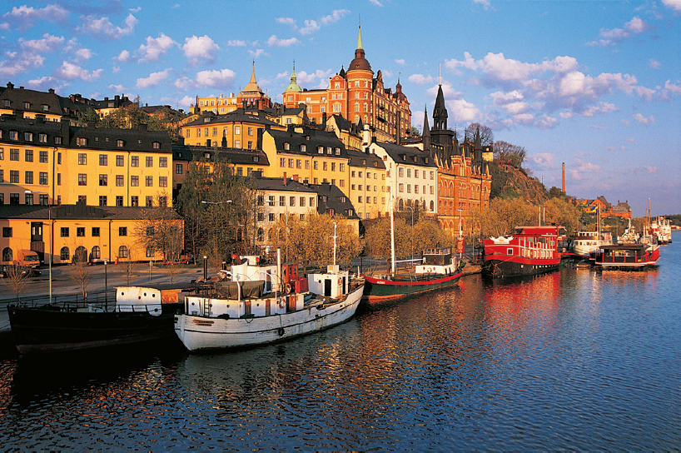4-5 September 2014 | Grand Hôtel | Stockholm**

**EXPERTS IN INTERNATIONAL ARBITRATION**

The role of expert evidence has become essential in today’s complex international arbitrations, with the outcome of many proceedings turning on a “battle of experts”. Concurrently, a professional class of experienced experts focusing on international arbitrations has emerged, in turn giving rise to thorny issues respecting impartiality and independence, duties owed to the tribunal, conflicts of interest and confidentiality. In view of these developments, various conceptual and practical questions related to the role and conduct of experts in arbitration are becoming of crucial importance for counsel, arbitrators, the courts and participating experts themselves.

This year, the Swedish Arbitration Days will bring together some of the most renowned and prominent arbitration practitioners and experts from around the world to discuss some of the key issues arising in relation to the use of experts in international arbitration.

We look forward to seeing you in Stockholm.

Organizing Committee

*Robin Oldenstam, Gisela Knuts, Domitille Baizeau, Sophie Nappert, Richard Kreindler, Matthew Weiniger, James Hope, Anders Reldén, Tore Wiwen-Nilsson, Jean-Claude Najar and Pontus Ewerlöf*

Click here to go to registration page.

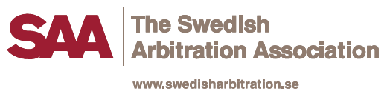

CONFERENCE PROGRAMME

**THURSDAY 4 September 2014**

08.30-09.00 Registration

09.00-09.10 Opening of conference – Swedish Arbitration Association Chair

09.10-09.40 Key Note Address – Mark Kantor/Independent Arbitrator (US) and Mike Pilgrem/FTI Consulting (UK)

09.40-11.10 **Session 1 – Expert Evidence – trick or treat?**

Moderator: Nadia Darwazeh/ Curtis, Mallet-Prevost, Colt & Mosle (Frankfurt/Paris)

Panelists: Nicholas Good/KPMG (UK), Kathleen Paisley/Ambos (US), Kaj Hobér/Mannheimer Swartling (Sweden) and Isabelle Hautot/Orange (France)

What is, or what makes, an expert witness? The role of expert witnesses in contemporary arbitration. Party- vs. Tribunal- appointed expert witnesses. Legal experts, technical experts, financial experts and confidentiality experts. Can we speak of a professional “class” of arbitration experts? If so, is this desirable? How do expert firms approach such development? How do they meet the standards of knowledge and conduct expected? What are their thoughts on related ethical considerations?

11.10-11.30 Break

11.30-13.00 **Session 2 – How to select an expert witness and deploy expert evidence efficiently**

Moderator: Bart Legum/Salans (France)

Panelists: Amani Khalifa/Hafez (Egypt), Robin Oldenstam/Mannheimer Swartling (Sweden) and Ermelinda Beqiraj/PwC (UK)

How do you deploy expert evidence effectively and efficiently? How do you select an expert witness? ICC proposal of experts and how it works in practice. Selection process and interviews? What characterizes a good expert witness? Do the expert fees matter in the appointment process? Assessment of expert evidence by the Tribunal and how counsel’s case strategy might take this into account. Conflicts of interest and expert witnesses. What principles or guidelines should apply? What is the significance of previously expressed opinions? The issue of industries having only a select few experts appearing repeatedly? Quantum experts from firms which also serve as auditors of the hiring party. Duties owed by experts to the Tribunal?

13.00-14.00 Lunch

14.00-15.30 **Session 3 – Expert Reports**

Moderator: Tatyana Minaeva/Stephenson Harwood (UK)

Panelists: Johan Sidklev/Roschier (Sweden), Eric Schwartz/King & Spalding (France), Domitille Baizeau/Lalive (Switzerland), and Peter B. Maggs/University of Illinois (US)

How should the expert report be written? Do’s and don’ts with regard to expert reports. What should an expert report contain, and what not? What does the Tribunal wish the report to contain? The cost/benefit of e.g. lists of issues for the experts and meetings of experts. To what extent should the Tribunal invite the parties to present expert witness testimony in a certain way, e.g. in the form of a joint report? What is the expert’s view on the drafting process? May counsel contribute to the drafting and if so, how and to what extent? How to handle a report based on or containing confidential information or privileged information? Can production be ordered of earlier drafts of expert reports and of communications with the expert?

15.30-16.00 Break

16.00-17.30 **Session 4 – Examination of Expert Witnesses**

Moderator: Pontus Ewerlöf/MAQS (Sweden)

Panelists: Roland Ziadé/Linklaters (France/Lebanon), Maria Kostytska/Winston Strawn (France/US/Belarus), Nish Shetty/Clifford Chance (Singapore) and Laura Hardin/Charles River (US)

What is the best way to examine expert witnesses at a hearing? Do’s and don’ts with regard to examination of experts. Preparation of expert witnesses for examination. How should the examination-in-chief, if any, be conducted? Should the expert make a presentation? What does the Tribunal prefer? What is the expert’s view on the best way to present his/her conclusions? Expert conferencing – good or bad and how should it be done, and how can it be enhanced or undermined? What to do if the expert is part of the legal team and not proffered for cross examination?

18.00 Reception and dinner at the Grand Hôtel

**FRIDAY 5 September 2014**

09.00-10.30 **Session 5 – Expert Proceedings – A convenient dispute resolution method or just extra hassle?**

Moderator: Ben Holland/Covington & Burling (UK)

Panelists: Lars Edlund/Swedish Supreme Court (Sweden), Sébastien Besson/Python & Peter (Switzerland), Marianne Ramey/PAI World (US) and Hannah Tuempel/ICC (France/Germany)

What are expert proceedings? In what situations/fields do expert proceedings add value, and in what situations do they not? Administered or ad hoc expert proceedings ? When should parties opt for expert determination resulting in a contractually binding result versus expert proceedings with a non-binding result? Jurisdiction and competence-competence of the expert. Should the expert have the power to decide which party should ultimately bear the cost of the expert determination? The enforceability of the result of an expert determination. The interplay with subsequent/concurrent  arbitration proceedings. The scope of the expert determination versus the scope of the arbitration clause. Expert determination in the form of arbitration proceedings?

10.30-11.00 Break

11.00-12.00 **Session 6 – Experts/non-lawyers as arbitrators**

Moderator: Julia Zagonek/White & Case (UK)

Debaters: Ulrike Gantenberg/Heuking Kühn Lüer Wojtek (Germany), Amir Ghaffari/Berwin Leighton Paisner (UK), Louise Barrington/Independent arbitrator (Hong Kong), Nael Bunni/Independent arbitrator and consultant (Ireland) and Annette Magnusson/SCC (Sweden)

A debate regarding experts/non-lawyers as arbitrators where the debaters have been given pre-assigned views to defend. The participants will debate the pros and cons of appointing an expert/non-lawyer as arbitrator. Is technical/financial expertise on the tribunal best secured by appointing an expert as arbitrator? Experts as sole arbitrators and as members of three- member tribunals?

12.00- Closing of Conference – Swedish Arbitration Association Chair

REGISTRATION

Fee: Early bird rate of SEK 6 000 (approximately euro 700) for registrations made before 30 June 2014. Ordinary rate thereafter of SEK 7 000 (euro 800). The registration fee includes attendance at the conference at the Grand Hôtel, documentation, refreshments during breaks, lunch on the first day of the conference, and the reception and dinner on the first day of the conference.

Registrations may be made through the SAA website – [www.swedisharbitration.se](http://www.swedisharbitration.se) – under Swedish Arbitration Days or by following the link below.

**Click here to register**

Accommodation is not included. Participants are asked to make their own hotel arrangements. Preferred Hotel partner for the Swedish Arbitration Days is Grand Hôtel in Stockholm. It is a five star hotel and also the conference venue. Preferred rates will be available until 4 August 2014 and reservations should be made online at https://www.yourreservation.net/tb3/?bf=HLLW1502&iataNumber=SWEDARB14&rateAccessCode=\*NJNA$**.**

Alternatively, you may choose Scandic Hotel Anglais at Humlegårdsgatan 23 in Stockholm. It is a four star hotel and preferred rates will be available. Reservations should be made online at www.scandichotels.se with reference to code No BSAA140914.

THE SWEDISH ARBITRATION DAYS 2014 IS SPONSORED BY

http://87.237.215.134/filearchive/2/23259/Gernandt_Danielsson.jpg http://87.237.215.134/filearchive/3/37019/Danowsky_logo190.jpg

http://87.237.215.134/filearchive/4/44842/vinge.jpg http://87.237.215.134/filearchive/2/28363/frank_advokatbyra.gif

http://sccinstitute.se/filearchive/2/23264/mannheimer_swartling.jpg http://87.237.215.134/filearchive/2/23270/Roschier.jpg

http://87.237.215.134/filearchive/2/23249/cederquist.jpg 

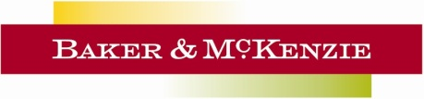 http://87.237.215.134/filearchive/2/23274/White_Case.jpg

http://87.237.215.134/filearchive/2/24862/Lindahl_stand.jpg http://87.237.215.134/filearchive/4/46063/Logga%20Hammaskiold.jpg

http://87.237.215.134/filearchive/2/23263/Linklaters.jpg C:\Users\beatrice.lofling\AppData\Local\Microsoft\Windows\Temporary Internet Files\Content.Outlook\OPLVMSTX\Norburg-Scherp-logotyp-1 1.jpg

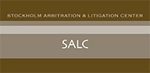 

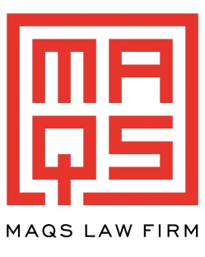 C:\Users\lsund\AppData\Local\Microsoft\Windows\Temporary Internet Files\Content.Outlook\VY5NUHEN\FTI_Logo_rgb-190pixels.jpg